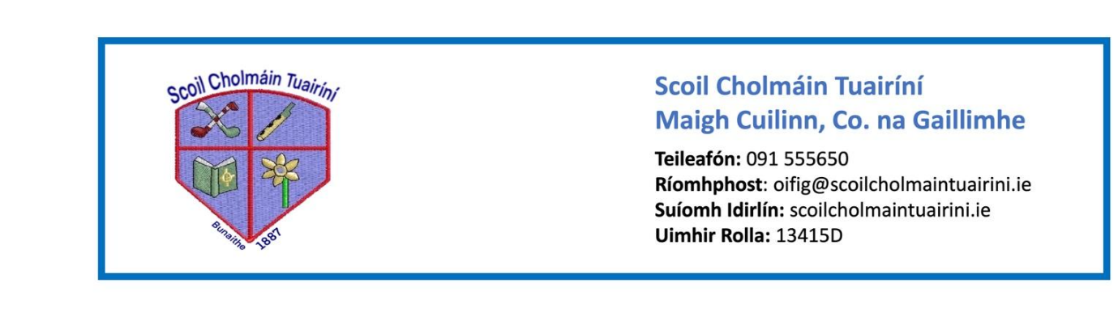 **Stáiseanóireacht Naíonáin Shóisearacha 2025/26**

* Pencil case with 3 x junior triangular pencils, 3 x erasers,a simple topper, small ruler and twistables (each one labelled with initials). It is better if the pencil case has two compartments, one for pencils and one for colours
* 4 x Whiteboard markers
* 3 x large glue sticks (bring in and leave in school – label with initials)
* 2 x A4 plush mesh storage wallets with zip
* 1 x A3 mesh wallet to store large art pages
* 3 x Medium-sized play doh (unscented)
* Packets of tissues for nose wiping and sneezing
* Headphones (wired)

**Reminder**

Naíonáin Bheaga will have a shortened day for the first two weeks of school and will finish at 12pm from 28/08/25 – 12/09/25.

Normal pick up time of 1:40pm will begin from Monday, September 15th.