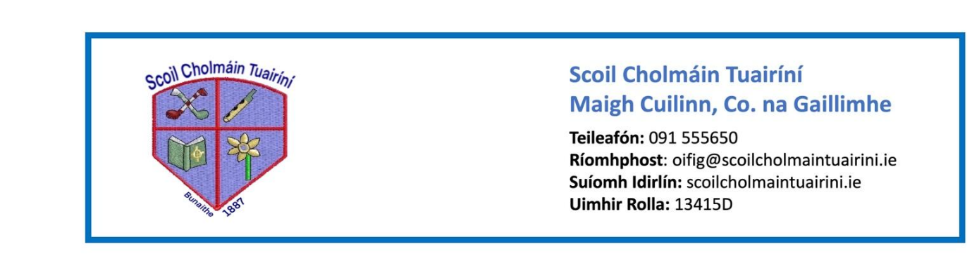 **Stáiseanóireacht Naíonáin Shinsireacha 2025/26**

* Pencil case with 3 x junior triangular pencils, 3 x erasers, a simple topper, small ruler and twistables (each one labelled with initials). It is better if the pencil case has two compartments, one for pencils and one for colours
* 4 x Whiteboard markers
* 3 x large glue sticks (bring in and leave in school – label with initials)
* 2 x A4 plush mesh storage wallets with zip (re-use last year’s if it is in good condition)
* 1 x A3 mesh wallet to store large art pages (re-use last year’s)
* 3 x Medium-sized play doh (unscented)
* Packets of tissues
* Headphones