Titanic

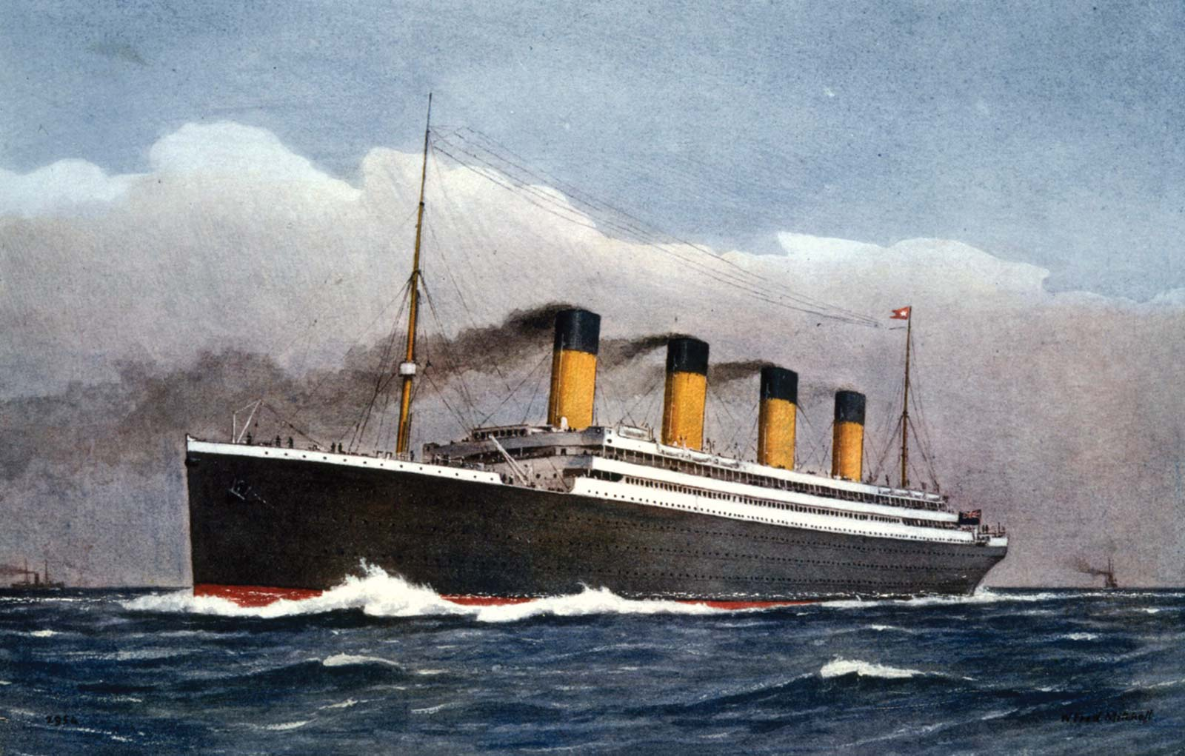
By
Senan Ward

Facts about the Titanic:
• The Titanic was built between 1909 and 1911.
• It was 882 feet (269 metres) in length and 175 feet (53 metres) in height.
• The Titanic had a crew of around 900 people.
• The Titanic’s engines were powered by pressurized steam from burning coal.
• It was a luxury passenger ship. It had some of the world’s richest people as well as others passengers looking for a new life in North America they were emigrating.
• The Titanic intended course was sailing from Southampton, England to New York City, USA.
• It left Southampton on April 10, 1912 and stopped in France and Ireland before heading west towards New York.
• It collided with an iceberg and sank on April 15, 1912.
• While the Titanic carried over 2200 people, there were only enough life boats for around 1200 of them.
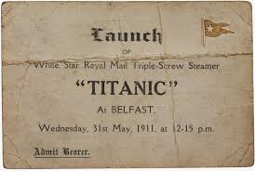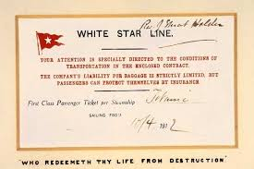
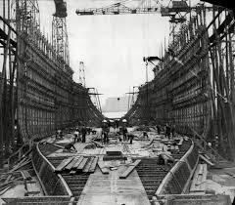
Titanic being built in Belfast.
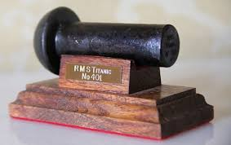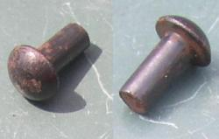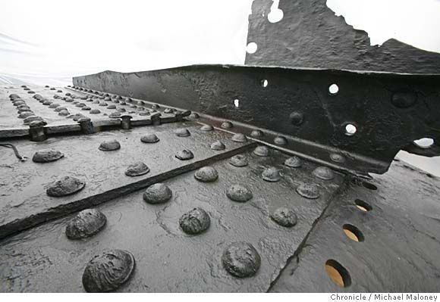

How much did it cost to be on the Titanic?

The cost of a First Class ticket was $4,350 (£875). It was $1,750 for a Standard Class ticket and $30 for a Third Class ticket.
The Third Class tickets were mostly for families who were emigrating to the United States.
In many cases they had sold everything to get onto the Titanic and to give them some money to get started in America.

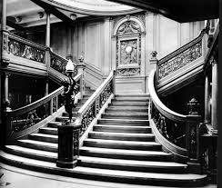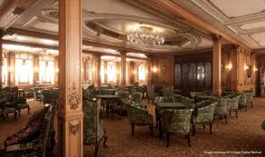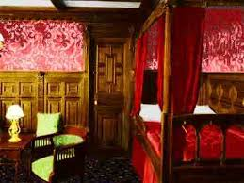

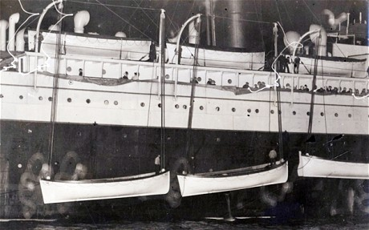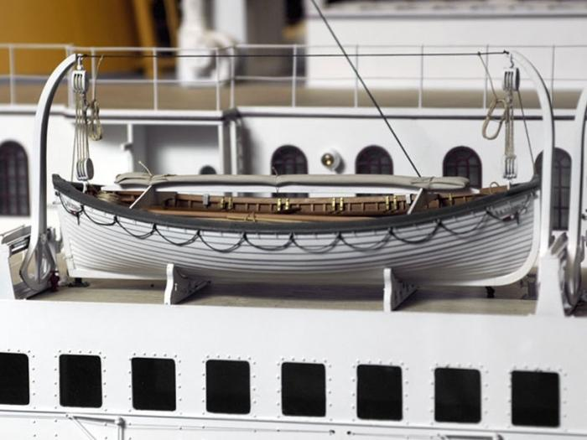
Who was to blame for the sinking of the Titanic?
On 14 April 1912 the Titanic received warnings of icebergs in the area from other ships. The lifeboat drill for that day was cancelled by the Captain, so the crew didn’t know what to do. After the second iceberg warning the ship changed course, which ended up being a big mistake as it took it right into a collision course with the iceberg.
More warnings came, but Captain Smith didn’t receive them. He also didn’t receive the final one at 9.40pm that night.
At 11pm the crew on the ship “Californian”, sent a message to say she’d stopped sailing due to icebergs, but the acting captain wasn’t interested.
The fatal iceberg was 15 miles (24 kilometres) away. There was no wind and the waters were calm. This actually made it more difficult to spot icebergs as you couldn’t see water breaking up against it.
Titanic hit the iceberg at 11.39pm. When the Captain put out a distress signal, the nearest ship – the Californian – 20 miles (32 kilometres) away, had turned off her wireless.
The ship Carpathia – 58 miles (93 kilometres) away – sent a message to say she was on her way, but she was actually four hours away. Lifeboats were launched, but lots of them weren’t actually very full.
By 2.20am the Titanic slipped beneath the freezing water which could kill people quickly. By 4.10am the Carpathia arrived and the captain Arthur Rostron said: “Except for the [life] boats beside the ship and the icebergs, the sea was strangely empty…”
By 8.30am the Californian arrived after realising the disaster and by 8.50am the Carpathia sailed for New York with 705 survivors and many dead.
It was a very sad occasion.
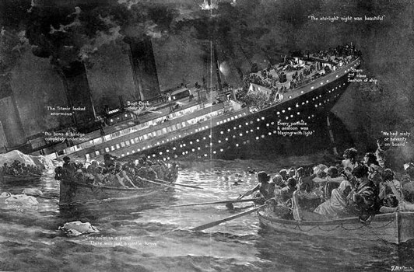

Is anyone from the Titanic alive?

The last living survivor of the Titanic, Millvina Dean, has died at the age of 97 in Southampton after catching pneumonia. As a two-month-old baby, Dean was the youngest passenger on board.

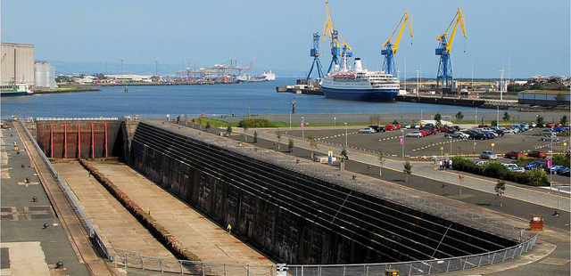

Did Harland and Wolff build the Titanic?

The Titanic was built at the Harland and Wolff shipyard, on Queen's Island, Belfast, Ireland.

Does Harland and Wolff still build ships?

Harland & Wolff's last shipbuilding project was a ship, built by German shipbuilders, was launched in 2003.

Who is Samson and Goliath?

The cranes are situated in the shipyard of Harland & Wolff and were constructed by the German engineering firm Krupp, with Goliath being completed in 1969 and Samson, in 1974.

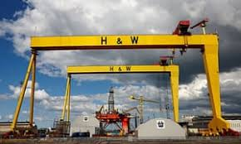

What is the height of Samson?

Samson, has an overall height of 106m (348 ft) with a height of 80m (263 ft) from the tracks to the underside of the bridge girders.

What is the height of Goliath?
Goliath stands 96 metres (315 ft) tall, Goliath, the smaller of the two sits slightly further inland closer to Belfast City.

Lunch menu.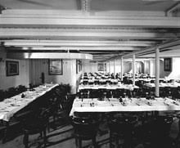 2 & 3 Class. 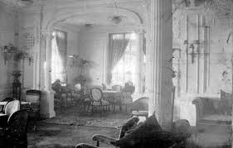 First class. A boy that survived.

