THE
TITANIC

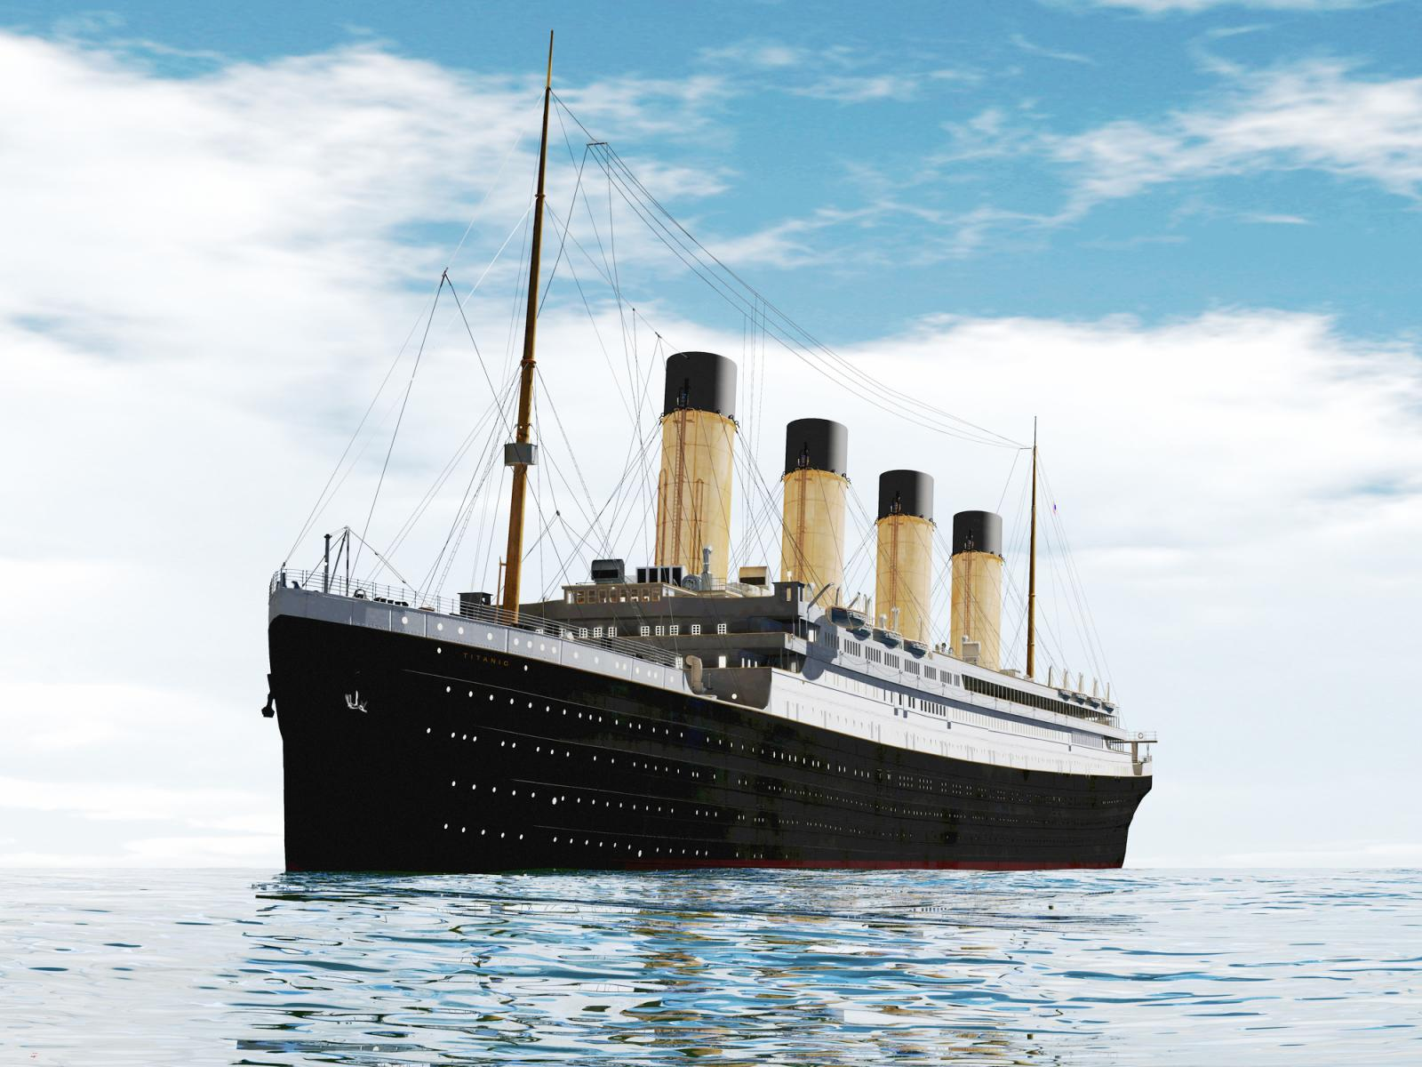

FACTS
ABOUT
THE
TITANIC

The Titanic was built between the years 1909 to 1912
There where 324 passengers in first class
There were 285 passengers in second class
There where 708 passengers in third class
There were not enough lifeboats onboard the ship the reason for this was it did not look good
All the lifeboats were not filled to capacity
During the building of the ship there were 246 injuries and 2 deaths recorded
A lifeboat drill scheduled for April 14th was cancelled for an unknow reason
LAST SURVIVOR OF THE
TITANIC

Millvina Dean was born on the 2nd of February 1912 her father was Bertram Dean her mother was Georgette Dean and her older brother was Bertram Dean. She was only 9 weeks when she boarded the Titanic from Southampton. Millvina, her brother and mother survived but her father didn’t

Millvina, her mother and brother were rescued by the ship the Adriatic and brought to England. Several of the other first and second class passengers wanted to hold her and take pictures with her, this was because it gave hope that such a small baby could survive such a tragic event. It was only when Millvin was 8 that her mother told her that they had been on the Titanic. Millvina and her brother attended Greggs school Southampton.

Millvina never married she worked for the government in World War 2 she drew maps for the government. It wasn’t untill she was in her seventies did she become a Titanic celebrity. She appeared on a few TV shows. In April 1996 she visited Belfast for the first time as a guest of honour in Titanic Historical Society convention. She died on 31 may 2009.
DOGS ON THE
TITANIC

There were 12 dogs on the Titanic. There was a Toy Poodle ,a Fox Terrier,an Airedale, a French Bulldog , a Pekinese, two Pomeranians . That’s all the dogs breeds I don’t think they knew the rest of the breeds. Only 3 of the 12 dogs survived the Titanic. The 3 dogs that survived the Titanic were the two Pomeranians one was called Lady and the Pekinese called Sun Yat-Sen.

The 3 dogs that survived were really small, they were smuggled onto the life boats. The Pomeranian called Lady was owned by Miss Margaret Hayes. Lady shared a cabin with her owner and was wrapped in a blanket and smuggled onto the lifeboat. The Rothschild family owned the other Pomeranian and the Harper family owned the Pekinese.

