Animals that changed the world

By Seán O’Donnell

We have learnt a lot about animals that changed the world. Here are more interesting facts.

LEECH
Leech bites are often painless so are not always obvious, however blood stained socks and clothing are a clue to their presence. When leeches bite, their teeth clamp onto the skin and with a suction like action start to feed on the host's blood. Leeches feed for around 30 minutes but are known to feed for longer.

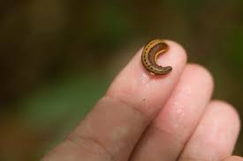

SILKWORM
The silkworm (Bomb mori) is the larva or caterpillar of the Bombyx mori moth. Silk has been made for at least 5,000 years in China. The moth is important because it makes the silk, and no longer lives in the wild. It is entirely dependent on humans. Silkworms eat mulberry leaves, and were native to northern China.
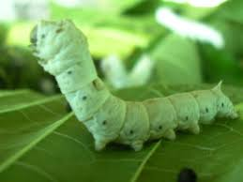

MOSQUITO
Mosquitoes are stimulated by a number of factors when seeking out a blood meal. Initially, they're attracted by the carbon dioxide we exhale. Body heat is probably important too, but once the mosquito gets closer, she will respond to the smell of a potential blood source's skin.
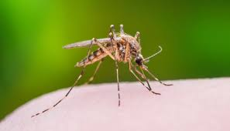
HONEYBEE
Honey bees can thrive in natural or domesticated environments, though they prefer to live in gardens, woodlands, orchards, meadows and other areas where flowering plants are abundant. Within their natural habitat, honey bees build nests inside tree cavities and under edges of objects to hide themselves from predators.

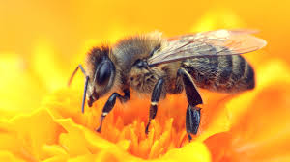

RAT
They live in yucca, palm and cypress trees, as well as in elevated areas of human homes. Roof rats can be found living in attics, rafters, eaves and on roofs. They may also choose to nest in non-arboreal vegetation, such as shrubs, honeysuckle and tall grasses.

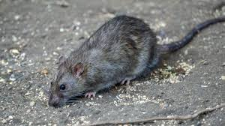
OYSTER
The Galway oyster festival is a highlight in the west of Ireland's festival calendar. It is the world's longest running Oyster Festival and one of the most internationally recognised Irish events. The 2020 event is expected to take place from Friday, September 25th to Sunday, September 27th 2020 at the Nimmos Pier Marquee.

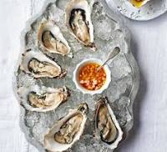

EARTHWORMS
Earthworms and their relatives live anywhere there is moist soil and dead plant material. Earthworms are most abundant in rainy forest areas, but can be found in many habitats on land and in freshwater. All earthworm species need moist soil conditions to survive. Earthworms have 5 hearts.
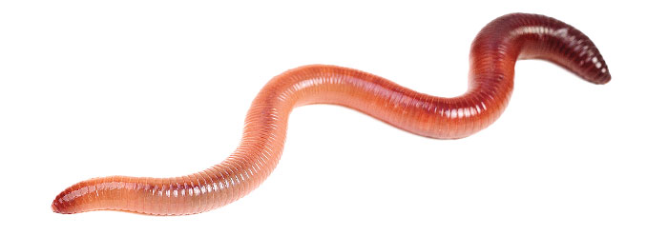

HERRING
Herring is in the top bracket and the FDA recommends to eat herring (and other “superfish”) three times a week. While fresh herring has the most nutritional benefits, canned herring is also full of antioxidants, Omega 3 fatty acids and other valuable nutrients.
