INTRODUCTION

TITANIC BY ADAM HAYAT

THE TITANIC WAS A SHIP BUILT AND LAUNCHED IN BELFAST ON MAY 31 1911.
IT WAS THE LARGEST MAN MADE OBJECT EVER MADE. THERE WAS A SAYING THAT GOD NOR MAN COULDN’T SINK HER. A total of 3547 people could fit in the titanic. THE TITANIC SAILED TO SOUTHAMPTON ON ITS ONLY VOYAGE EVER ON APRIL 10TH 1912. IT HAD FOUR RESTAURANTS, SHUFFLEBOARD, A SWIMMING POOL, SQUASH COURTS, A GYM AND IT HAD 39 LUXURY SUITES AT THE TOP OF THE SHIP. IT WAS VERY EXPENSIVE TO GO IN FIRST CLASS

HOW IT SANK

ON APRIL 15TH 2 20 AM THE TITANIC STRUCK AN ICE BERG. CAPTAIN SMITH GOT SEVERAL ice berg WARNINGS THAT HE IGNORED. AFTER A SUDDEN JOLT THE SHIP HIT AN ICE BERG. IT TORE THROUGH THE SHIP AND DOZENS OF PEOPLE DIED BECAUSE OF THE COLD WATER LEAKING THROUGH THE SHIP. AS THE PEOPLE RAN TO THE TOP OF THE SHIP IT SNAPPED AND TONNES OF PEOPLE FELL INTO THE WATER AT 2 DEGREES CELSIUS WHICH AT THIS TEMPRATURE PEOPLE WOULD START TO DROWN

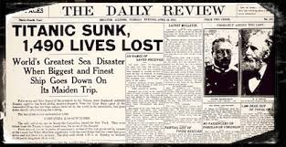
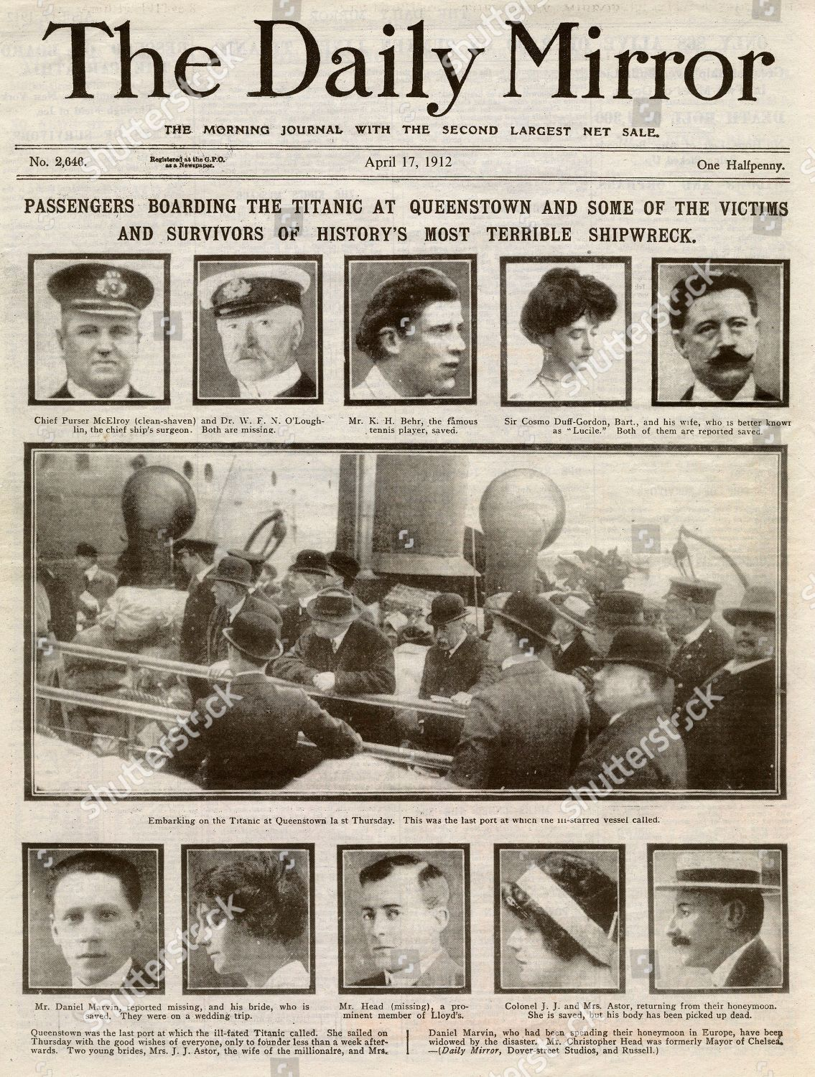

WHERE IT SANK

THE TITANIC SANK APROXIMATELY 400 MILES FROM NEWFOUNDLAND, CANADA . IT WAS CARRYING 2200 PASSENGERS GOING TO NEW YORK FROM SOUTHHAMPTON. 1,514 PEOPLE DIED THAT MORNING ON THE TITANIC. WHILE THE TITANIC WAS SINKING A BAND WAS PLAYING ON IT AND SADLY ALL THE BAND MEMBERS DIED. THERE WERE NOT ENOUGH LIFE BOATS ON THE SHIP WHEN IT SANK. THERE WERE ONLY 20 LIFE BOATS FOR 2200 PEOPLE ON BOARD THE SHIP
IT WAS MADE OF MILD STEEL AND IRON RIVETS THAT GOT RIPPED APART WHEN IT STRUCK THE ICE BERG

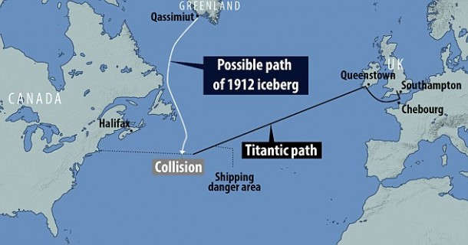

survivor

The last survivor FROM THE TITANIC DISASTER MILLVINA DEAN DIED AT THE AGE OF 97 AFTER CATCHING PNEUMONIA IN SOUTHAMPTON. AS A TWO MONTH OLD BABY SHE WAS IN THE 3RD LEVEL OF THE SHIP. SHE WAS PUT ONTO A LIFE BOAT. SHE WAS THE YOUNGEST PASSENGER ON BOARD THE TITANIC WHEN IT SANK ON ITS MAIDEN VOYAGE TO NEW YORK.
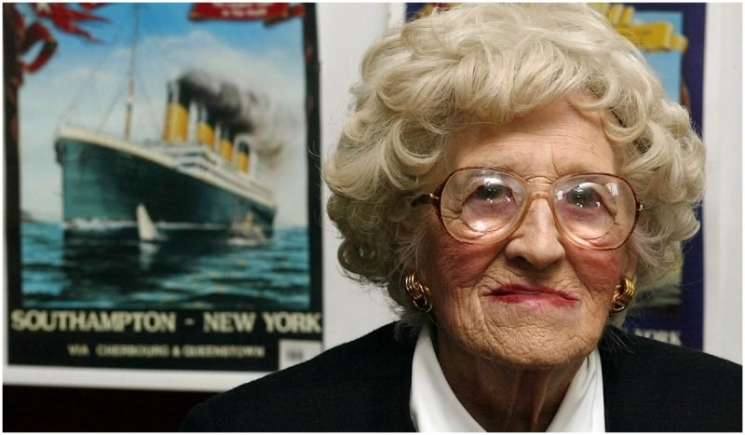

ANIMALS ON BOARD

THE FIRST CLASS PASSENGERS WERE ALLOWED TO BRING THEIR PETS ON BOARD THE TITANIC TO WALK THEM AND FOR COMPANY, BUT THE TITANIC ANIMALS LOCKED UP AT THE BOTTOM WERE TOTALLY DOOMED AS THE TITANIC SANK FROM THE BOTTOM AND THE DROWNED. THERE WERE 12DOGS, FOUR HENS, FOUR ROOSTERS, 30 COCKERELS, ONE YELLOW CANARY AND THE SHIPS RAT CATCHER JENNY THE CAT.
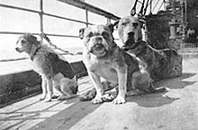

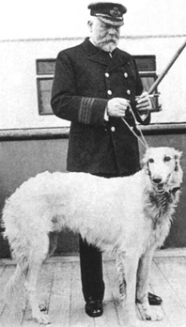
CAPTAIN SMITH

EDWARD JOHN SMITH ALSO KNOWN AS CAPTAIN SMITH WAS THE CAPTAIN OF THE TITANIC WHEN IT SANK. DURING THE SAILING OF THE SHIP TO NEW YORK THE CAPTAIN IGNORED SEVERAL ICE BERG WARNINGS WHILE ABOARD THE SHIP. HE DIED THAT DAY AFTER HE WANTED TO GO DOWN WITH THE SHIP. HIS LAST WORDS WERE ‘WELL BOYS DO YOUR BEST FOR THE WOMEN AND CHILDREN AND LOOK OUT FOR YOURSELF ‘ AS THE CREW MEMBERS LEFT TO GET PEOPLE ON THE LIFE BOATS

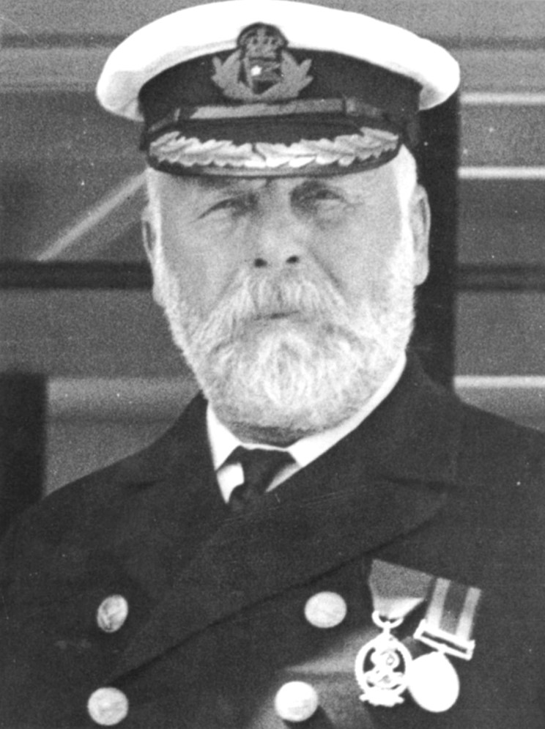

MAIDEN VOYAGE

THE TITANIC SAILED TO SOUTHAMPTON ON THE FIRST LEG OF ITS JOURNEY ITS ONLY VOYAGE APRIL 10TH. Captain Edward john smith was also the captain of the TITANICS voyage from Belfast to SOUTHAMPTON NOW I WILL TELL YOU ABOUT THE CLASSES IN THE SHIP.

WHAT WAS IT LIKE
1ST CLASS

FIRST CLASS IN THE TITANIC WAS NICE AND WAS FULL OF LUXURY, INCLUDING A SWIMMING POOL AND FANCY RESTAURANTS IN FIRST CLASS. IT WAS A BIT EXPENSIVE BUT NOT THAT EXPENSIVE. IN THE RESTAURANT, A LIVE ORCHESTRA PLAYED WHILE YOU ATE YOUR FIVE STAR FOOD. IN THE SWIMMING POOL THERE WERE MARBLE PILLARS HOLDING THE ROOF UP AND A PRETTY BIG POOL.

2ND CLASS

SECOND CLASS WAS LIKE A SMALLER VERSION OF FIRST CLASS, JUST NOT THE RESTAURANTS AND THE ORCHESTRA AND NOT THE POOL, BUT IT WAS STILL A GREAT EXPERIENCE ON A VERY BIG BOAT. THE ROOMS ON 2ND CLASS WERE GOOD AND SIMPLE AND NICE.

3RD CLASS/STEERAGE

THIRD CLASS WAS NOT GREAT, CONSIDERING THAT THERE WERE 6 PEOPLE IN ONE ROOM WITH OTHERS IF YOU WERE TRAVELLING ALONE, BUT WAS OK FOR BIG FAMILIES. THE THIRD CLASS PASSENGERS WERE LIMITED TO A CERTAIN NUMBER OF THINGS ON THE SHIP. FOR EXAMPLE, THEY COULD NOT GO INTO THE POOL OR SOME OF THE RESTAURANTS AND THEY COULD NOT BRING THEIR PETS ON TO THE SHIP

MORE FACTS ON THE TITANIC

1. THE TITANIC WAS BUILT BETWEEN 1909 AND 1911.

2. IT WAS 882 FEET [269 m] AND 175 FEET [53 M] IN HEIGHT.

3. THE TITANIC HAD 900 CREW MEMBERS.

4. THE TITANIC WAS POWERED BY PRESSURISED STEAM FROM BURNING COAL.

5. THE TITANIC WAS THE LARGEST MAN MADE OBJECT AT THE TIME.

HOW LARGE WAS THE HOLE

THE VERY LARGE HOLE THAT THE ICBERG CAUSED RIPPED THROUGH THE SHIP CAUSING A 12 SQUARE FOOT. THERE WERE ALSO SIX HOLES AFTER THE TITANIC HIT THE ICE BERG. THE TITANIC SANK NOT BECAUSE OF HOW BIG THE HOLES WERE BUT ACTUALLY BECAUSE OF THE LOCATION OF THESE HOLES IN CRITICAL AREAS OF THE SHIP.

IT WAS A TERRIBLE TRAGEDY. 1514 PEOPLE DIED. THERE IS A MEUSEAM IN BELFAST ABOUT THE TITANIC.

END

BY ADAM HAYAT

